Students

Al-Hubaishi Waleed iCompetence

Kaminsky Jens Informatik

Coaches

Kalunder Madlaina  
Agotai Doris

How to create a cool App <todo>

**Swiss Engineering  
Event App (SEEA)**

IP5 Documentation 2019-XX-XX

# Summary

The goal of this project is to create an app for the Swiss Engineering Association that will attract new members. To achieve this goal, a voice recognition/generation feature was suggested. This Document will summarize how such a feature could be implemented, what is currently possible and even what might be possible in the future by looking at cutting edge research that is currently being done in this section.

# Abstract

This project is focused on how to transfer the Swiss Engineering Web platform booking events process into a mobile app. Where the database used for both the web platform and the app must be the same.

The objective of this project is facilitate booking events process using the apps, so that the Swiss Engineering members can totally rely on it to manage their booked events and explore what is available on the platform. The app has been implemented using XAMARIN Cross Platform app developing tool to ensure that no matter which device the members have in their pockets; whether iOS or Android may enjoy the intuitive experience of booking, managing and exploring the events.

The mixture of working with Agile methods while focusing on the usability experience (UX) resulted in an intuitive to use graphical user interface, where all important elements related to the core features of the app are well presented in the home page screen, so that the end-users, no matter what age group they belong, or what technical affinities they possess can enjoy the app and use it without any need for tutorials or help on how to navigate through the different app screens.

# Management Summary

At the beginning I focused on understanding what elements does XAMARIN offer us the developers to deal with and what limitations do exist. Then the decision were made, considering the Personas, to offer the simplest type of designs that the Persona can deal with and have no problems understanding how to interact with the elements and navigating through the available screens. Therefor the main screen includes all the core features buttons, distributed into two groups, while the main feature of the app, which is the built in assistant feature, is represented at the top in full width.

Another important part was to find a suitable assistant service to accomplish the tasks requested, and as the options were limited from the start to choose from three candidates, which are the major player nowadays on the market, namely Google Assistant, Apple Siri and Amazon Alexa, we have decided to go with the Google Assistant service for a number of reasons, the most important may be the ease of use, and the huge infrastructure, resources and the tutorials available and invested from Google to develop their service.

Using both XAMARIN and Google Assistant, simple user interface and logic behind it, this Swiss Engineering Event App was created. The app offers an intuitive workflow to accomplish the end-users goal, and contains simple user interface elements, that the user must know already its meaning and what is its purpose, based on end-users previous experience dealing with the other apps.

The workflow starts from the main screen and user is asked to navigate back to the main screen in order to start working with another feature, while this gave the simplicity element, but I would personally rather have mixed structure instead of a linear workflow. The end-user needs three clicks at max on the back button to go back to the main screen, or as an element of easiness, a click on the logo of Swiss Engineering should bring the end-user back to the main screen as well, although this is not really a mobile application approach and more web-sites, but it was a necessity to implement it this way, in order to really use every single element displayed on the screen.

The requirements gathering process didn’t include the end-user from the Swiss Engineering Organization, but a sample of potential end-users who are indeed engineers from different fields and backgrounds were consulted in order to know what do they really need in an event app, and what information do they count on to make a booking decision. Nevertheless for a future update, the Swiss Engineering end-users should be consulted and be involved to refine the design and data offered.

An extended list of features should be also added to the built in assistant to expand the services it offers, and not only to save tags and view answer simple questions, but to book apps directly for instance.

A major limitation that was faced during the implementation and designing phase, is the lack of an appropriate data base structure to include all the new attributes that must be saved for each end-user, for example the liked tags and a well-defined attributes information, as the content of the location attribute was not only the actual address, but an inconsistent address information such as only the name of the location, and sometimes the street name and number without postal code. So a re-built database should make the output and displayed information more reliable on the app.

Another major flaw, is that the process of reserving events is too inconsistent at the moment and varies from an event to another, sometimes the user should contact the organizers to book and sometimes the end-user may be able to book the event directly, therefore a consistent process of booking will definitely benefit the app in the future, so that the end-user might book an event directly without having to navigate to the Swiss Engineering website to see how to proceed with the booking process.

**Revisions list**

|  |  |  |  |
| --- | --- | --- | --- |
| **Version** | **Date** | **Comment** | **Author** |
| 0.5 | 26.04.2019 | Initial Version with the template elements | Jens Kaminsky |
| 1.0 | 28.04.2019 | Technical Research & a part of the introduction | Jens Kaminsky |
| 2.0 | 16.5.2019 | Abstract, Management summary, state of the art, methodologies, topic in depth and completed the introduction. | Waleed Al-Hubaishi |

Table of Contents

Introduction 5

Research (FACTS) 6

state of the art 6

ASR 6

Visual-only recognition of normal, whispered and silent speech 7

Multilingual speech recognition with a single end-to-end model 8

Methodologies 9

Feature extraction 9

Voice Classifier/Identifier 10

Topic in depth 12

Evolving search engines 12

Communication in service providers 12

Voice biometrics as authentication 12

Smart Assistant 12

Forensic Department 13

Technical research 14

Google assistant 14

Siri Assistant 16

Alexa Voice Service (AVS) 17

concept 18

Prototypes, design, details 18

implementation 18

Analysis & future thoughts 18

attachments (sources, literature) 18

literature references 18

honesty policy 18

# Introduction

Swiss Engineering is an association that spans over multiple professions and has a total of around 13’000 members in Switzerland. They are holding over 100 events annually over multiple of their Sections. These events are not only for current members also have the additional benefit of attracting new future members.

The Swiss Engineering association is currently in the process of updating their event booking website. To reach a greater audience they intend to also have a native mobile app to make booking on the go easier. This application would also be showcased on events with the idea to improve the image of the Swiss Engineering by showing that it has a modern app.

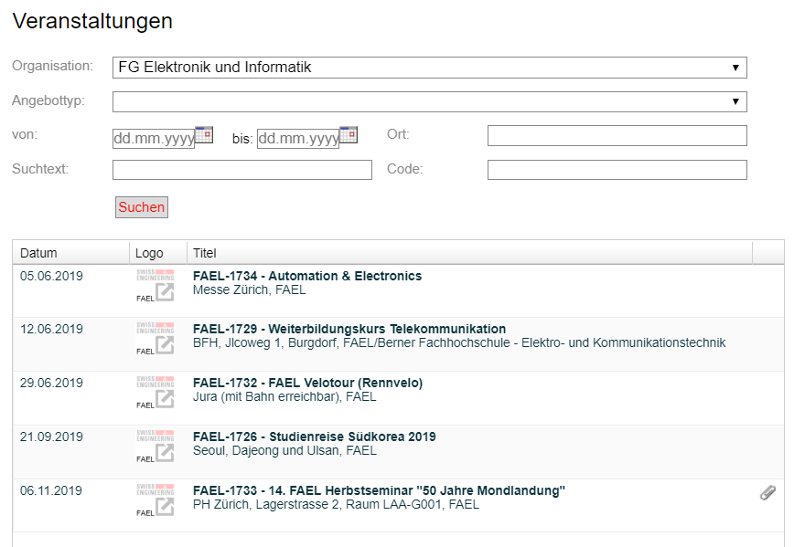

The IP5-Swiss engineering event app team aims to build an app with a simple UI design that helps the Swiss Engineering members to accomplish their goals at a glance and reach the needed piece of information within a sequential and logically ordered number of screens, so that no tutorials are need to know how to use the app and also all Personas can use the app intuitively no matter which technological affinities they possess.

The idea is not overload the app with a ton of features, but to keep the app simple and direct, and present only the features that the Persona wishes to see and have in an event app, so that the Persona keep focus and concentrated and not easily distracted by the UI elements.

In order to achieve that, the IP5 team used the UX knowledge that were gathered during the semesters to design a clean and neat user interface that accommodates to the user experience with the other apps that the end-user used during the years.

Another important element was considered while designing the app which is number of clicks needed to accomplish a task, so that is why the app has the advantage enabling the end-users to reach their goals in a less number of steps compared to the Swiss Engineering website.

All of this was done by offering the features requested by the client and also a sample of potential end-users who are indeed engineers and contributed to the success of the app design by giving their list of features they wish to have and also the type of information that could made up their decision on whether or not to book an event.

Also in order to improve the app functionality, a number of features were added to help the users get the most out of the app, such as the tagging system, which helps to recommend events to the members, by receiving the input of the built in assistant and convert it into suggestions and recommendations that might interest the members.

Last but not least, the social aspect of the Swiss Engineering organization was also addressed by offering a feature inside the suggestions system which helps the members to meet familiar faces and make new friends who shares a similar taste and interests.

# Research (FACTS)

After presenting what is the team of SEEA aiming for, now is the time to start exploring what is available on the market, and what are the latest technologies used on the field to accomplish one of the most important features in the project, which is the built in assistant.

In the following chapters the latest developments to the Voice Recognition field will be discussed, and how could those benefit the app greatly.

## state of the art

This chapter includes the state of the art algorithms that are used nowadays in the Speech Recognition field.

Some of the algorithm that were discussed and explored are not related to the goal that the voice assistant in this project must accomplish, rather an interesting algorithms that might be added in the feature to extend the algorithm used in the project and add extra value and functionality.

One of the major algorithms that were interesting to read about and search for was the Lips Movement speech recognition as it will provide the opportunity to implement the search event feature for instance via speech recognition, where the end-user must not say the words out loud when the situation is not suitable for that.

### ASR

the idea of Automatic Speech Recognition ASR is to translate the input voice into a written text. And because of the recent development, such algorithm exists nowadays on the majority of smart phones via the built in voice assistant apps such as Google assistant for Android devices and Siri on iOS devices, not only that but on every single smart speaker that contains the voice recognition such as amazon Alexa.

Those ASR model has benefited greatly from the development of deep neural networks, yet there is still a major challenge ahead, such as dropping the out a big part of the training data, and had therefor hard time sometimes recognizing a word when the training data dropped out contains the set of parameters containing that word.

Data augmentation has helped a lot regarding this matter, the same way it helped before in the process of classifying images. The way it is used in the process of ASR is to extend the number of data used to train, not by adding more learning data by adding new files that size might be large, but by manipulating the existing data to offer another version with but with different parameters, for instance the voice can be used as is to provide one learning data, then speeding up or lower it down to provide two different versions of the same data used.

This trick may be applied the same way it is applied in the image processing and classifying, by not manipulating the image itself, or the voice in our case, but manipulating its corresponding spectrogram to create a different version of the same uploaded file that will require no more extra space. The results were surprisingly good, and effective.

Figure 1 training data with two other versions created from it

### Visual-only recognition of normal, whispered and silent speech

Another interesting state of the art algorithm that might be helpful to use in the noisy or in contradiction the loud places is the visual speech recognition.

The Idea behind the visual speech recognition is to not use the voice to recognize the words but rather to use the lip movement, that would absolutely not help to accomplish the goal of this project but it was a really interesting idea to discover.

As you have expected this model will not use the microphone or audio files to get its learning data but it will use the video instead to detect the lips movement and link it to the desired word, but as the header indicates, this model is not about only about silent speech, but also whispering and talking out loud as well as talking normal.

This algorithm requires that the 4 different models corresponding to each of the 4 possible context should be included in the same algorithm, and therefore the AI should learn each word 4 times. The question raised is whether or not could the AI return the correct interpretation of the movement when the mode(context) is not specified while testing.

The biggest challenge to implement this model was that the lip movement changes according to the context in which it is said, for instance the word “success” would have four different lips movement model, depends on whether it has been said silently, whispered, normal speech or said out loud. There is still a big chance that a word might be confused with another one in a different context if the mode is not set correctly while testing, or if the training data of a single context were not provided.

The results out of testing this algorithm showed a big success and state of the art results when the context has been set and the training data has been provided while testing. On the other hand the performance dropped by a big margin when the mode(context) has not been set, or when the training data of the set context has not been provided but another context training data.



Figure 2 capturing the lips movement

### Multilingual speech recognition with a single end-to-end model

This model is pretty interesting, as it provides the possibility to combine multiple languages under the same model, so that at the end the algorithm may decide to which language does this sentence belong.

The algorithm idea is not new, rather it is an improvement over an already existed model (Listen-Attend-Spell attention based sequence-to-sequence ASR by William Chan) so that it can be adapted to help the purpose of differentiating the languages.

The idea of this algorithm is to include a set of languages, let us say L1 … Ln in a set L, and also include their corresponding characters in a set for each, in this case we have C1 … Cn, at the end we have also the language specific training data set which consists of (X1,Y1) for the first language till (Xn,Yn) for the language Ln.

The trick here is that we should be able to retrieve all the training data sets in one big training set, and all characters Set (C) as well.

Afterwards the big training data set is used to train the model, with no indication given which language does this training data set belongs to. But where is the trick ?

The trick is that this test was done over 9 Indian languages, which have a rare percentage of intersection of words and characters, so a small number of words may be used in more than one language, in this case we made sure that word X for instance will have most of the time only one language where it belongs to as the number of intersection is very limited, so the total number of words recognized will help us to identify the language used as we still have the set of all training data separated according to the language it represents.

So at the end when the model finishes recognizing the words, a probability shall be calculated to which language does a sentence belong to, based on how many words came from each language separately, thus the language with the highest probability will most likely be the one which the sentence belongs to.

## Methodologies

The voice recognition is considered to be another input alternative rather than the textual classical way of entering input to the machine via keyboard. In this sub-chapter the various types of voice detection and recognition shall be introduced.

All different types of voice recognition requires two modes in order for it to work appropriately, which are:

1. Training mode

In training mode a huge amount of samples must be collected – the more the better – in order to train the system no matter if it was Speaker dependent or independent.

The samples must be words or even sentences captured by a microphone which is the input device in this case.

1. Testing mode

Acoustic/audible characteristics must be analyzed out of the input sample, and then the important features shall be extracted out of it.

The feature vectors are then used to generate an input pattern which will be saved in a form of a matrix, then the unknown pattern when entered must be compared with all the input values in the matrix, and the best match found should be considered to be the correct interpretation and perform the action that it leads to.

### Feature extraction

So after this small introduction, let us explore now the different type of feature extraction techniques wish will be used afterwards to train the system.

#### Linear Predictive Coding (LPC)

This tool is considered to be the most trendy and powerful among all. In LPC we examine the input speech in a frame-based manner to produce vectors.

The LPC requires a pre-emphasize, which surpass the input speech, then the output of the pre-emphasizer must be blocked into frames, afterwards shall each frame be windowed, so that we can reduce the amount of signal disruption at the starting and the end of each frame.

Finally each windowed frame is auto correlated, and the maximum value of the correlation is considered to be the order of the LPC analysis and used afterwards to return the LPC coefficient which is the result we seek.

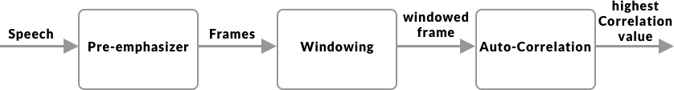

Figure 3 LPC

#### Perceptual Linear Prediction(PLP)

It is similar to the LPC, but the captured speech must be adapted to the psychophysics of human hearing. Its spectral features differs from the normal LPC in way that matches the human auditory system, so therefor it rejects a lot inappropriate information (filtering) which might be caused by the speaker, but non-hearable by human frequency captured.

#### Relative Spectral Filtering(RASTA)

This technique serves the same purpose as the PLP, but it helps to drop out/filter the voices (frequencies) caused by the background noises that are not related to the speech itself, so if this technique was combined with the PLP, then the results should be brilliant, then the Rasta passes each feature coefficient only.

It also includes a linear filtering of trajectory of power spectrum in the case of the noisy speech.

#### Mel Frequency Cepstral Coefficient(MFCC)

The word Mel would face any researcher about the topic of speech recognition, and that is for a good reason.

MFCC has huge achievements in the field of speech recognition, because it doesn’t offer only the possibility of recognizing the speech, but also the speaker.

The MFCC processing method is based on short-term analysis, which means that for each frame an MFCC vector must be computed, thus it is considered to be the best among all when it comes to estimate the human system response.

In order to obtain the coefficient (the result we seek in all types of speech recognition techniques) we apply a hamming window to the input (speech sample) in order to reduce the disruption of a signal.

At the end a Discrete Fourier Transform (DFT) must be used to produce the Mel Filter Bank.

To calculate the MFCC the following formula can be used.

Mel (f) = 2595*log10 (1+f/700).

### Voice Classifier/Identifier

So after that features have been extracted from the signals, those features should be used to train the system to classify the words spoken. Here is a list of most commonly used classifiers.

#### Hidden Markov Model(HMM)

This model is trendy and an easy approach when it comes to classify words. It is based on huge vocabulary speech recognition systems, characterized by a finite state Markov model and a set of output distributions, and automatically trained on large speech data for many hours, thus comes its major advantage which decreasing the time and the complexity required for training the huge vocabulary in the system. Unfortunately this advantage led also its major limitation, which is the complexity to find the error of its scheme in order to enhance the performance.

#### Neural Network(NN)

Neural network are used mainly to solve complex identifications tasks, and they have also many number of advantages over the others, such as its ability to function independently of the speaker (unknown speaker) and its ability to work with noisy data. When compared to the HMM, the neural network provides much more better accuracy, especially when the amount of training data is large as HMM is used mainly when the number of training data is limited.

The neural networks is being used also in phoneme recognition, and therefore we have also a combination called NN-HHM, where HHM is used for the language modeling, and the neural network for the phoneme identification part.

#### Dynamic Time Warping(DTW)

Dynamic Time Warping uses dynamic programming to perform the optimization process of identifying the similarities between two samples, the first is the original, and the second is the manipulated version of it. That is why it has been used to identify the manipulated versions of voice, video or even images. But it is not used as often compared to the other techniques due to its continuity issues.

#### Vector Quantization(VQ)

The VQ is considered to be among the best when it comes to save time, space and the computation effort. VQ is basically a function mapping process, where it maps a word or input from a large space, into a smaller space called cluster, this cluster is identified by a code word, those collection of code words construct a code book.

Using the VQ method, a new codebook is constructed for each speaker, thus it may recognize the speaker even. This constructed codebook acts as a pre-recorded words for the user, then used when the speaker is being tested to be identified or to recognize what does the speaker say in the system.

When it comes to Voice Recognition, the VQ is used to retain the high speaker recognition rate as a parameter to identify elements like number of speakers for instance as well as the size of training database.

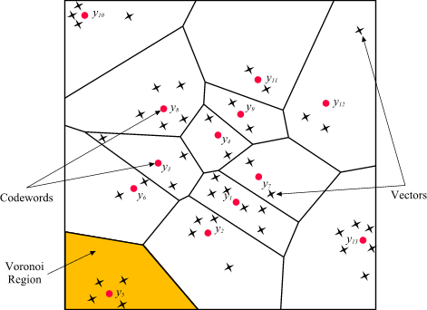

Figure 4 Codewords in 2-dimensional space. Input vectors are marked with an x, codewords are marked with red circles, and the Voronoi regions are separated with boundary lines (Source: http://www.mqasem.net/vectorquantization/vq.html)

## Topic in depth

This sub-chapter will go through the fields where the voice recognition is mostly used and in which context does it help to accomplish a specific purpose. At the first glance, one might think that voice recognition is used only for the smart assistant or voice messages, but it really did improve many other fields, that no one might consider the impact of voice recognition to those, and here are some.

### Evolving search engines

The search engines nowadays have become a necessity in our lives, but we find sometimes difficulties expressing what do really mean in verbalized words, and would prefer to say our query more naturally, here exactly came the benefit and the impact of voice recognition.

It is not meant that we search our queries via voice, although that is also an option on the major search engine such as Google for instance, yet it is meant that the search engine use the voice recognition training data entered daily and the intent behind it to give back better search results with high percentages of accuracy.

### Communication in service providers

With the higher number of services available nowadays, we can only imagine how many customers does each of those have, therefor the high number of technical support calls and guidance request, unfortunately that might lead to a long waiting periods on call till the customer been redirected to the technical assistant.

That has arisen the need of an innovative solution to help the customers get the guidance they needed in a short amount of time, thus is the voice recognition integrated.

In this situation the customer doesn’t have to enter any numbers using the keypad, yet the customer should be able to speak more naturally and let the smart assistant guide him/her through the problem solving process.

### Voice biometrics as authentication

This model has been used even in Switzerland by some companies, Sunrise telecommunication for instance, as they would ask the customer to use a sample of the voice to get its biometrics and construct a model so that the customer doesn’t have to give a number of personal sensitive data which might take a while before illustrating the customer’s request and intent of calling.

The voice biometrics are not only used in the services company, but also to authenticate the unlocking process of the smartphone and also to give commands to the virtual smart assistant.

### Smart Assistant

Thanks to Amazon, Google and Siri, the smart voice assistant industry is growing rapidly nowadays and companies compete to provide a better experiences to their clients to acquire a bigger market share.

Voice assistant helps to accomplish mostly all types of task that we can think of, for instance setting up an alarm, playing music, calling contact, writing messages …etc.

Although a huge amount of people still consider the breakage of their own privacy, nevertheless the smart assistant is the considered to be the next big thing, especially when the companies start to expand the capabilities of the voice assistant as Google did for instant with the Dublex feature presented last year.

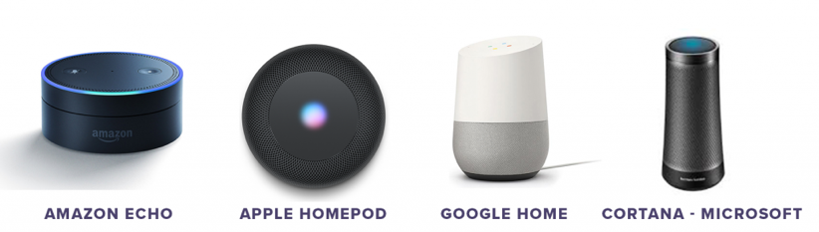

Figure 5 avaliable voice assistants on the merket (source: https://idfive.com/ideas/preparing-website-voice-recognition-usability/)

### Forensic Department

Although it may seem weird, but voice recognition has helped a lot so far in identifying criminals using their voice, in this case if a sample of the criminals voice was captured as the crime was committed, this sample can use later on to identify the criminal among a list of suspects by comparing their voices to the captured sample.

## Technical research

This section will go into depth about which existing implementations for natural language processing are available and how they could be integrated in the SEEA solution

### Google assistant

Google assistant is a platform independent natural language processor. It supports both Android and iOS devices.

It is recommended to use api.ai for the natural language processing in the background. Api.ai tries to extract intents and entities from the input.

#### Entity

Entities could be for example Animal.

The Entity Animal contains multiple different animals, e.g. dog, cat, bird, etc.

After creating a list of things that are part of the “Animal” Entity you can also help the A.I. by providing synonyms. E.g. A “Puppy” is also a Dog, “Dogs” can also be interpreted as Dog, etc.

#### Intent

Intents are actions that can be derived from phrases the user tells the program. E.g. “Tell Me A Joke” would be an intent, the program will be prompted to execute the task (intent). Like for entities, the developer needs to provide the algorithm with example sentences that should trigger the intent. The more examples are given, the more non predefined sentences the A.I. can use to trigger the intent.

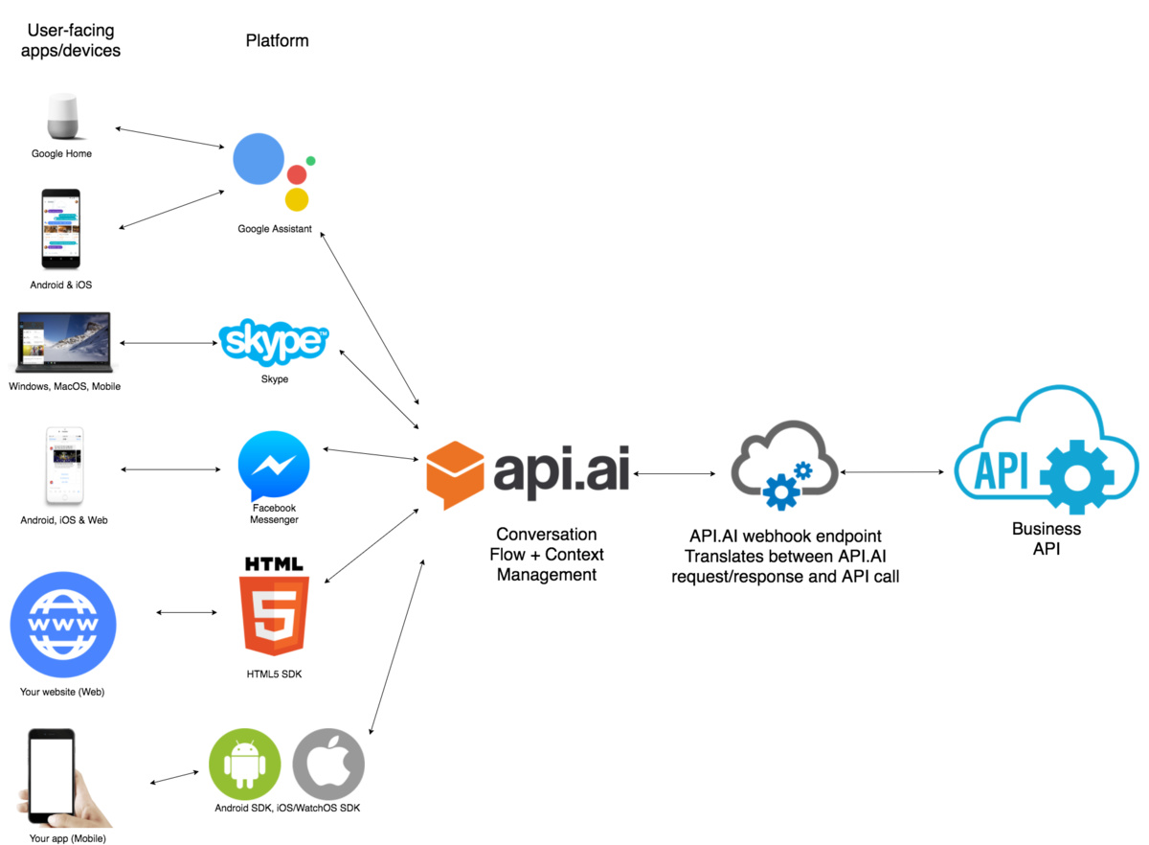

#### Pricing:

**Dialogflow Standard Edition** provides all of the core features of Dialogflow, but interactions are limited by usage quotas, and support is provided by the community and e-mail. It is ideal for small to medium businesses that want to build conversational interfaces or those who want to experiment with Dialogflow.

**Dialogflow Enterprise Edition** provides higher usage quotas and support from Google Cloud support. Dialogflow Enterprise Edition is a premium offering, available as a pay-as-you-go service. It is ideal for businesses that need an enterprise-grade service that can easily scale to support changes in user demand.

Available in two pricing plans:

**Essentials**: This plan contains all features offered by Dialogflow Standard Edition, plus enterprise-ready quotas for speech recognition, speech synthesis, and telephony gateway.

**Plus**: This plan contains all features offered by Essentials, plus enterprise-ready quotas for knowledge connectors. Each request from an Enterprise Plus agent performs the regular intent recognition and entity extraction, as well as a knowledge connector search.

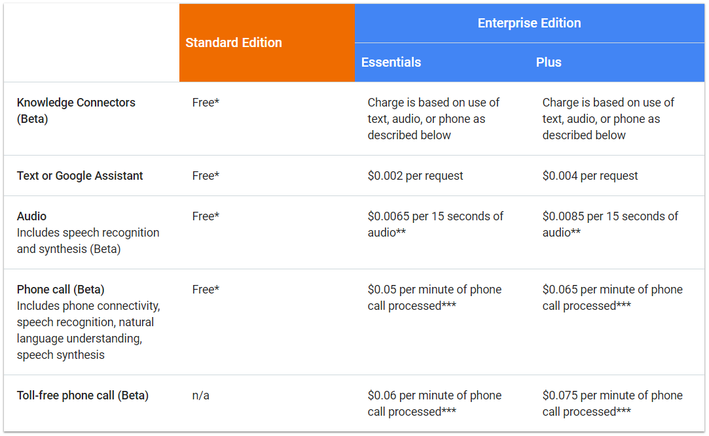

### Siri Assistant

The development environment of Siri is called SiriKit and it offers the possibility to translate calls to the assistant into calls for the app you want to use. For this to work an internet connection is mandatory as the voice data is sent to apple servers for the natural language processing.

Apple has a strict List of so-called Domains and Intents which the application call has to be assigned to for it to work.

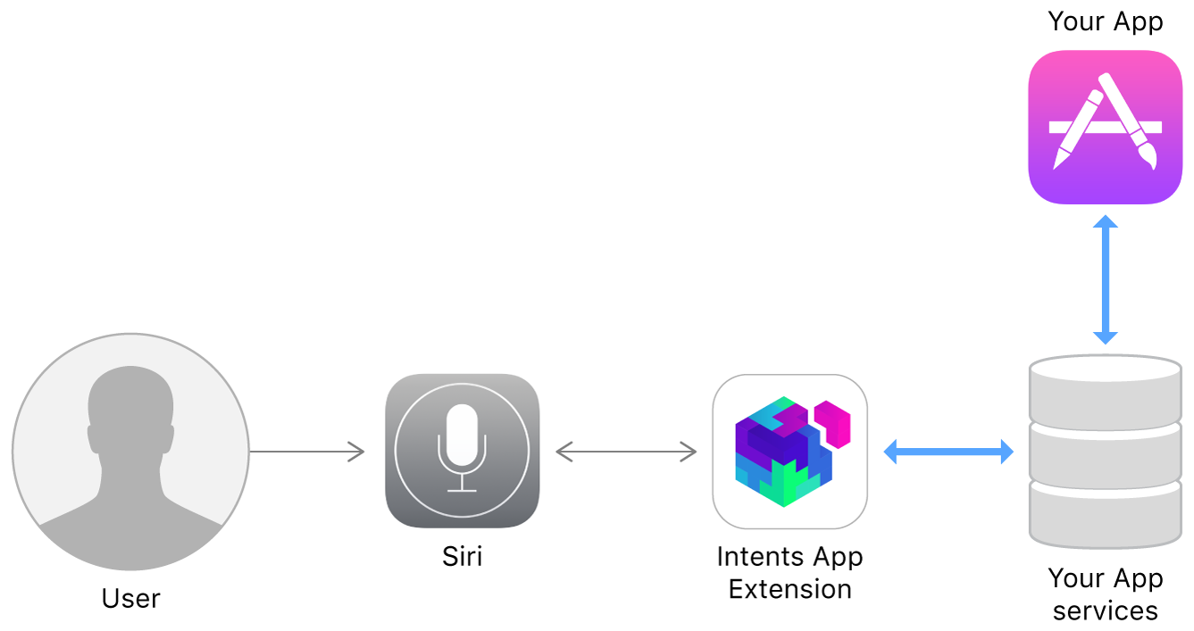

Domains:

* Lists: Simple list creation and editing
* Visual Codes: Display QR codes
* Ride Booking: Requesting a ride, this is intended for services like Uber
* Messaging: Simple text messaging
* Photo Search: Making a search request for photos and videos and display them.
* Payments: Creating a payment request or sending money
* VoIP Calling: Make a call (also supports video)
* Workouts: Starting, pausing and finishing a routine, explicitly specified as workout
* Climate and radio:

Pros:

+ Apple would take over the NLP part

Cons:

* Only works with an internet connection
* Domains limit the usability for the app
* Always requires specific keywords for it to work

### Alexa Voice Service (AVS)

AVS is a platform independent service that is used over an HTTP/2 api.

AVS is built like Siri in the way that it is task oriented. The tasks of AVS are called directives and events, the following are supported:  
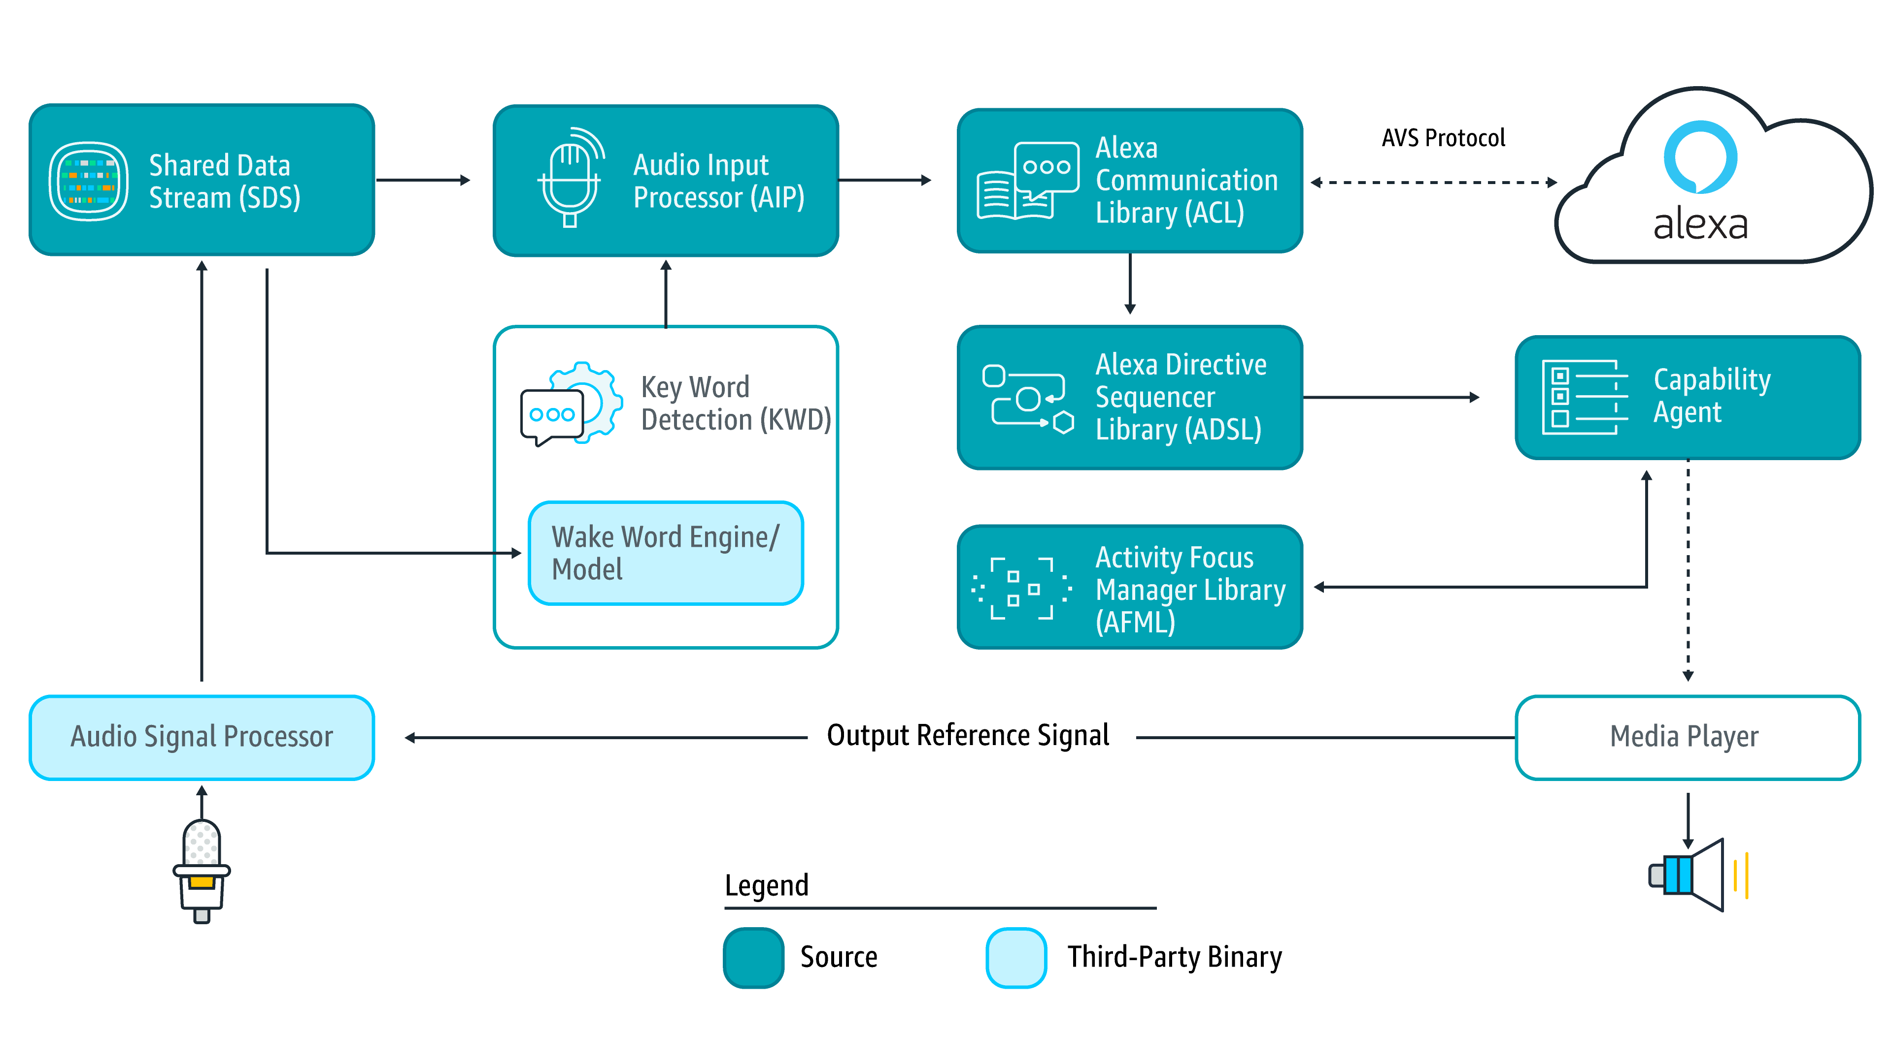

* Alerts: timer and stopwatch features
* AudioPlayer: control music playback, etc.
* Bluetooth: manage Bluetooth connections
* DoNotDisturb: enable DoNotDisturb mode on device
* EqualizerController: control equalizer settings and equalizer modes
* InteractionModel: Allow the client to support complex interactions and Alexa routines
* Notifications: API for notifications
* PlaybackController: navigate playback queue via GUI or buttons
* Speaker: volume control, mute and unmute
* SpeechRecognizer: API for speech capture
* SpeechSynthesizer: Text to Speech API
* System: System state
* TemplateRuntime: visualize metadata of requests

Pricing:

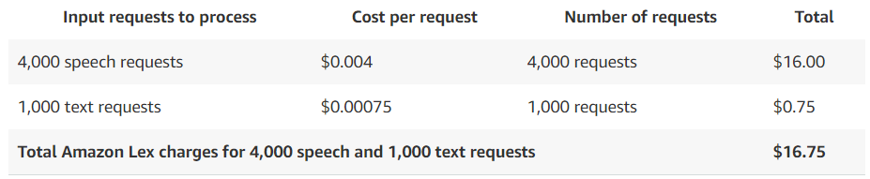

# concept

what did we come up with, what do we want to implement

Potential ideas

## Prototypes, design, details

# implementation

# Analysis & future thoughts

what's out of scope, what could be done in future

# attachments (sources, literature)

everything that might be interesting for the expert

# literature references

[https://github.com/alexa/avs-device-sdk 2019-04-26](https://github.com/alexa/avs-device-sdk%202019-04-26)

<https://aws.amazon.com/lex/pricing/> 2019-04-26

<https://developer.apple.com/sirikit/> 2019-04-26  
[https://cloud.google.com/dialogflow-enterprise/pricing 2019-04-27](https://cloud.google.com/dialogflow-enterprise/pricing%202019-04-27)  
<https://developers.google.com/actions/distribute/> 2019-04-28

<https://www.swissengineering.ch/index.php?option=com_content&view=article&id=4&Itemid=6&lang=de> 2019-04-28

<https://xamarinhelp.com/interacting-google-assist-xamarin/> 2019-04-28

# honesty policy